***Tripleten Hackathon December 2023***

**Research report**

**on Customers complaints   
in the US banking system.**

**Team:**

*Arina Sitnikova, Team Lead*

*Aleksandr Arkhipov, CTO*

*Ksenia Gormash, EDA & Analysis*

*Anton Moiseev, EDA & Analysis*

*Joshua Norfolk, Dashboards*

*Priyangka Roy, Dashboards*

*Rami Awadallah*

Contents:

**The business task description. 2**

**Questions for analysis: 3**

**The initial recommendations for FAQ: 3**

**EDA process: 4**

**Analysis 8**

Complaints on Products through the years 8

Most important Issues mentioned in customers’ complaints 9

Issue/Product cross-section 10

Targeting the FAQ for companies/states. 13

Timely response of the company 16

Adding the issues and products that appeared only in 2023 and could become hot topics 17

**Final result 19**

## The business task description.

*You’re working in the banking system. Your team has decided to help enhance support team processes in terms of dealing with customer complaints. You need to analyze what type of questions and complaints have been sent regarding loans and money transfers and categorize them so the support team will have a better understanding on what complaints types they can focus on in the first place to start creating their FAQ.*

**Thus, our main research question is**: *What are the prevalent types of customer questions and complaints related to loans and money transfers in the banking system, and how can they be effectively categorized to optimize the creation of a targeted FAQ?*

## 

## Questions for analysis:

1. Most common issues and sub-issues raised by consumers.

2. Analyze the distribution of complaints over time to identify trends or patterns.

3. Identify regions with higher and lower complaint rates

4. Analyze the distribution of complaints based on product types and sub-products categories.

5. Compare the performance of different companies in handling and resolving complaints

6. Examine the status of complaints and closure reasons like how many complaints have been closed, and what is the most common closure reason among 'closed,' 'closed with explanation,' 'closed with monetary relief,' and 'closed with non-monetary relief.

7. What sub-products have more complaints?

8. Specific types of complaints & certain states.

## The initial recommendations for FAQ:

1. Identifying most common issues and their concentration across (sub)products, states, time periods, companies.
2. Identifying fastest growing issues
3. Identifying new issues for 2023
4. Combining them into a multi-dimensional tree:

Dimension 1:

* + 1. Product category > Loans, Money transfers
    2. Product
    3. Sub-product

Dimension 2:

* + 1. Issue category
    2. Issue
    3. Sub-issue

1. Taking only issues that form the top 90% cases (up to discussion) cumulative.
2. Presenting FAQ structure.

## EDA process:

1. Investigated the structure and data types. The dataset covers consumers’ complaints about financial issues for the period Dec 2011 - Dec 2023, having around 4.4 mln rows. Some of these cases are explained in detail in the ‘Consumer complaint narrative’ field, some are left only tagged with product, sub_product, issue and sub_issue.
2. There are also fields for dates of submitting and receiving the complaint, for the company involved, the state where the complaint was submitted (with ZIP code), the state of the company's response and consumer satisfaction tags. Also, we have information on whether the consumer is protected by any special laws in the USA (service member or older American). There is also information on the channel through which the complaint was submitted: Web, phone, e-mail, etc.
3. ‘Consumer complaint narrative’ field is often empty. In this case, the tag field ‘Consumer consent provided’ contains the reason - no consent, or consent withdrawn, etc.   
   If the ‘Consumer complaint narrative’ field is not empty, then the tag field contains ‘Consent provided’ message in all cases.
4. Product and issue tags populate the whole dataset. Subproducts and sub-issues are blank in a substantial part of the dataset.

|  | date_received | product | sub_product | issue | sub_issue | consumer_complaint_narrative |
| --- | --- | --- | --- | --- | --- | --- |
| count | 4413134 | 4413134 | 4177843 | 4413134 | 3690184 | 1603040 |
| unique | NaN | 21 | 86 | 177 | 272 | 1334754 |

Take a notice that the Narrative unique values count is less than the total count on this field. This could mean implicit duplicates.

1. The team did the following:
   1. Removed implicit duplicates (all fields equal, except for Complaint ID field, and consumer narrative is not empty).
   2. Categorized the product into three types: ‘loans’, ‘money transfers’ and ‘other’. We are interested in the first two only. Of 4 mln cases in the original dataset, we are left with 1 mln. Categorization was based on product description and on the presence of keywords (‘loan’, ‘lease’ or ‘mortgage’) in the Consumer Complaint Narrative field.
   3. We didn’t include any cases that mentioned credit/debit cards. There were also a number of complaints on those, but card transactions are usually initiated by a seller, not by a customer, thus they should not relate to money transfers in the banking sense.
   4. Noticed that in 2017 the dataset (or rather the program used to input consumers’ complaints into the database) underwent drastic changes. Products, Sub_products, Issues and Sub_issues were renamed or restructured. Some appear only in the years 2011-2017, while other tags appear in 2017-2023 only. This begs for cutting the dataset at 2018 earliest, since the end goal is to build a FAQ, which should include only actual problems that appear in the recent years.  
        
      *Example: only 2015-2017 record an issue “Account status”, while only in 2017-2023 we have an issue “Account status incorrect”. This is obviously one and the same issue and the change happened somewhere in 2017.. Sometimes these similarities are not that obvious.*
   5. Cut the dataset, leaving only 2018-2023 complaints.
   6. Products, Sub_products and Issues were cleaned - similar entries were grouped together, different wordings (e.g. ‘...contacted before 8am’ <> ‘...called before 8am’) were standardized.  
        
      Some wordings appeared in 2023, when the database underwent another structural change. New (sub)products and (sub)issues appeared. In cases when these were obviously formulated in the same way, they were joined together with the older ones under the same name. If the wording of a product or an issue appeared unique, it was left in the dataset to form a special structure of new entries for the FAQ.   
        
      We decided that these (sub)products or (sub)issues could be lost in the sorting process, since they comprise small numbers of cases, appearing only in 2023. But since these were added to the input program in 2023, they could be new and actual, so we should not lose them.
   7. Sub_products, Issues and Sub_issues were run through a function that removed unnecessary words that created different spelling (‘I’, ‘my’, ‘your’, ‘a’, ‘an’, ‘you’, etc.).
   8. Issues (originally 177 of those, after cleaning - 65) were categorized into 10 general Issue categories. A function applied these categories to all rows in the working dataset.
   9. There was no need to categorize Products, since we were left with only 8 of those.
   10. Some Sub_products and Sub_issues were left blank in the dataset. It happened when a Product or an Issue didn’t have a variety of Sub_products or Sub_issues. In such cases, Product denominations or Issue denominations were propagated to corresponding Sub_product or Sub_issue fields.   
         
       *Example: rows with blank Sub_issue and Issue like ‘Unauthorized transactions/other transaction issues’ now have ‘ISSUE Unauthorized transactions/other transaction issues’ values in Sub_issue field.*

After the EDA, the final working dataset looks like this (main fields shown):

|  | date_received | product | sub_product | issue | sub_issue | consumer_complaint_narrative |
| --- | --- | --- | --- | --- | --- | --- |
| count | 637171 | 637171 | 637171 | 637171 | 637171 | 485859 |
| unique | 2172 | 8 | 46 | 60 | 192 | 413316 |

Unique narratives number is still less than the total number of narratives. Similar narratives exist in several rows with other fields varying values (we have dropped all rows that are totally identical already). So, these could be several issues coming from one narrative, and we cannot remove them safely, not knowing the reason for several inputs with the same narrative.

The number of Products, Subproducts and Issues is reduced substantially, so we can run the analysis with this dataset and choose only the most common Subissues later for the FAQ.

To get a bird fly view of the whole structure of issues, please refer to the following treemap. Let’s build a treemap of three levels:

1. Issue category (designed in the project)
2. Issue (from the original dataset)
3. Sub issue (from the original dataset):

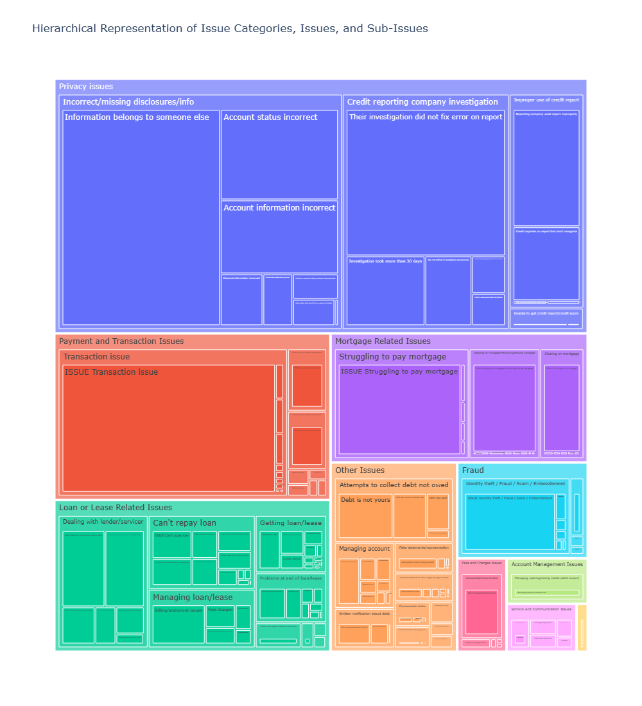

*Fig. 1. Treemap of Issues structure.*

This is a representation of comparative importance of Issue categories (colors), issues (rectangles) and sub issues (inner rectangles), by the number of complaints in 2018-2023.

Not all of them are going to be in the FAQ, obviously. While some issues have no sub issues, others would have over 20. So, we need to set a threshold at a level that would cover a considerable part of the sub_issues, not overloading FAQ.

## Analysis

### Complaints on Products through the years

First, let’s look at the banking/financial products that have issues. There aren’t many products related to loans and money transfers: only 8 of them (out of 21 in the original dataset). Here are their dynamics in terms of the number of complaints for each product per year:

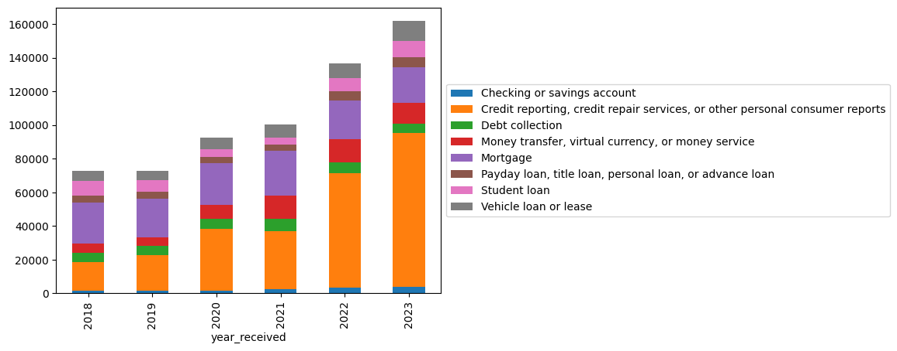

*Fig.2 Annual number of complaints by products.*

In recent years, the hottest issues deal with the incorrect information on credit reports. These were included into our dataset, because the keyword ‘loan’ was mentioned in the “Consumer complaint narrative”. So, it’s either a loan that has been paid off, but the credit report was not updated, or the report contains incorrect personal details of the borrower, or identity theft/fraud, i.e. appearance of loans in the credit report that a person didn’t take at all. There are other issues in “Credit reporting…” product, and we will see the most common ones later on.

There are only two products that are related to money transfers: “Checking or savings account” and “Money transfer…”. Only cases that had a notion of a transaction issue, or transfer issue, were included in the dataset. As such, they comprise around 10% of our working dataset, and 90% are related to loans.

There are 4 types of loan products:

1. Mortgage
2. Payday/title/personal/advance loan
3. Student loan
4. Vehicle loan.

These have their own issues, which are more often varying, than similar.

Finally, there is a “Debt collection” product, which predominantly deals with issues on collecting a loan from a wrong person or in a wrong way (for example, bothering the borrower’s relatives or employer).

All these products are distributed in the following way:

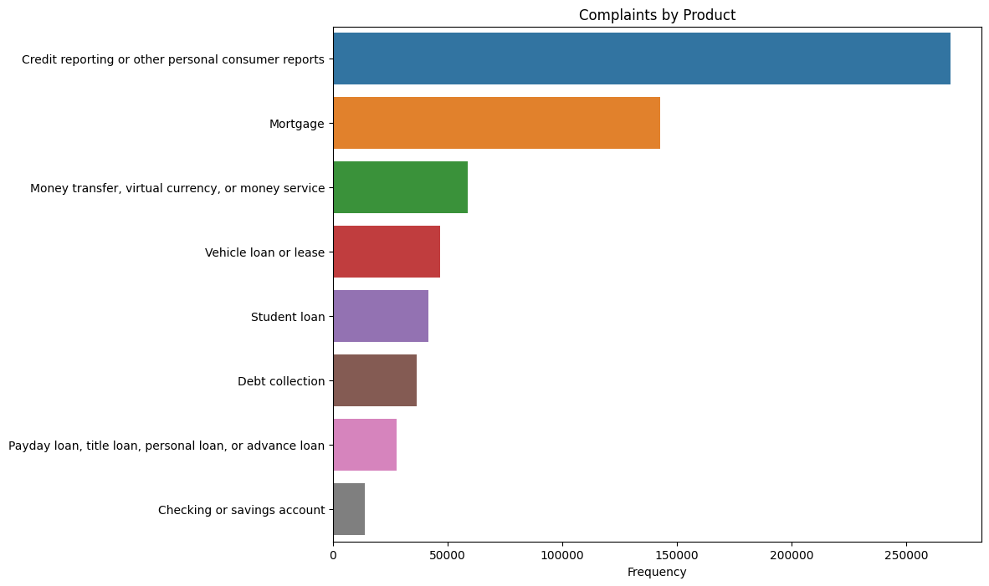

*Fig. 3. Total number of complaints by product*

### Most important Issues mentioned in customers’ complaints

Ten top issues among all relevant issues are shown in the following chart:

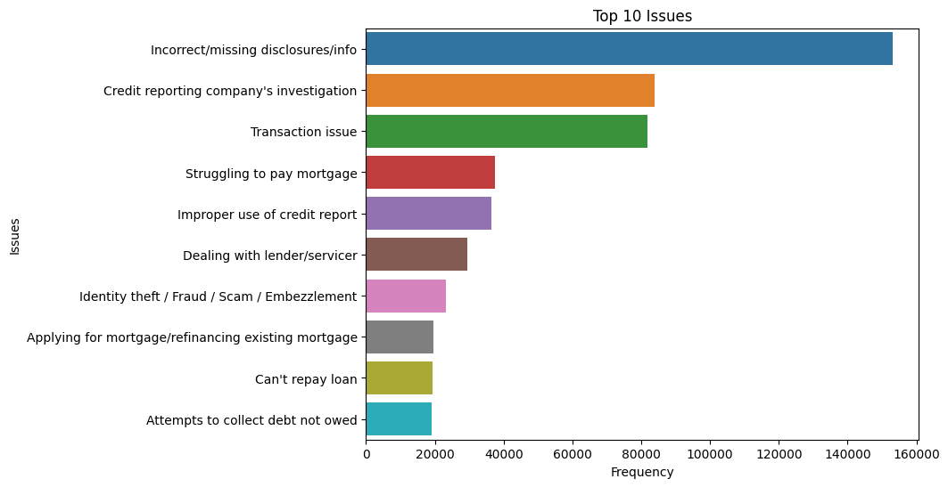

*Fig. 4. Top 10 Issues in the working dataset.*

We see most issues related to privacy, but also transaction and mortgage issues are important.

If we group all issues by category and put all of them on a timescale, we’ll be able to answer the question, whether some issues were abundant in a specific time period. This check is necessary to build the FAQ, since we don’t want to include obsolete issues. Let’s look at all issues, grouped into categories, on a timescale:

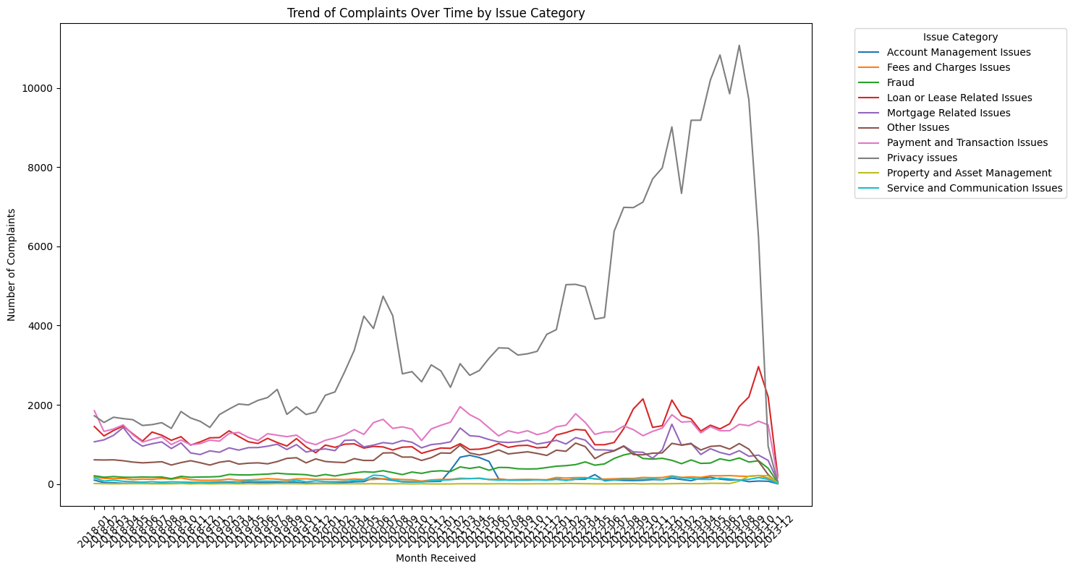

*Fig. 5. All Issues grouped into categories in 2018-2023, by number of complaints per month.*

As expected, privacy issues were on the rise, while others were stable or slowly rising. We will keep the important ones later, filtering out the rare ones.

How are these issues distributed among products? Are they specific for a product, or cover several products at once?

### Issue/Product cross-section

Let’s look at each product’s issues, compiled in a table. First, let’s analyze a table of issue categories against products. We will see, which issue categories relate to which product:

*Table 1. Product / Issue category cross-section.*

| product | Checking or savings account | Credit reporting or other personal consumer reports | Debt collection | Money transfer, virtual currency, or money service | Mortgage | Payday loan, title loan, personal loan, or advance loan | Student loan | Vehicle loan or lease |
| --- | --- | --- | --- | --- | --- | --- | --- | --- |
| issue_category |  |  |  |  |  |  |  |  |
| Account Management Issues |  |  |  | 7703 |  |  |  |  |
| Fees and Charges Issues |  | 160 | 7 | 2311 |  | 7126 |  |  |
| Fraud | 21 | 4262 |  | 21149 | 146 | 138 | 154 | 195 |
| Loan or Lease Related Issues |  | 17 |  |  |  | 10642 | 37874 | 38879 |
| Mortgage Related Issues |  | 1 |  |  | 69205 |  |  |  |
| Other Issues | 12882 | 145 | 36444 | 517 |  | 12 |  |  |
| Payment and Transaction Issues | 795 | 2 |  | 22077 | 68288 | 4689 |  |  |
| Privacy issues | 65 | 264542 |  |  | 5128 | 2753 | 3737 | 6984 |
| Property and Asset Management |  |  |  |  |  | 457 |  | 670 |
| Service and Communication Issues |  | 198 | 31 | 4956 |  | 1809 |  |  |

We can already conclude that while some categories are abundant in complaints, others are not very common (such as Property and Asset management - under this category we have issues of repossession, selling or damaging the property under loan, etc.). To concentrate on those issues that are prevalent, we could filter out all issues that make up for less than 0.5% of the whole relative complaints.

I.e., if our clean dataset contains roughly 600K cases, then all issues that make up for less than 3 000 complaints for a certain product would not be included (these figures are rough, not exact). The issues shown in the following table sum up to 93% of the ~600K cases.

*Table 2. Product/issue cross-section.*

| product | Checking or savings account | Credit reporting, credit repair services, or other personal consumer reports | Debt collection | Money transfer, virtual currency, or money service | Mortgage | Payday loan, title loan, personal loan, or advance loan | Student loan | Vehicle loan or lease |
| --- | --- | --- | --- | --- | --- | --- | --- | --- |
| issue |  |  |  |  |  |  |  |  |
| Applying for mortgage/refinancing existing mortgage |  |  |  |  | 19643 |  |  |  |
| Attempts to collect debt not owed |  |  | 19014 |  |  |  |  |  |
| Can't repay loan |  |  |  |  |  | 3965 | 7679 | 7812 |
| Closing on mortgage |  |  |  |  | 12208 |  |  |  |
| Credit reporting company investigation |  | 85481 |  |  |  |  |  |  |
| Dealing with lender/servicer |  |  |  |  |  |  | 29322 |  |
| False statements/representation |  |  | 4419 |  |  |  |  |  |
| Getting loan/lease |  |  |  |  |  |  |  | 6914 |
| Identity theft / Fraud / Scam / Embezzlement |  |  |  | 20435 |  |  |  |  |
| Improper use of credit report |  | 34560 |  |  |  |  |  |  |
| Incorrect/missing disclosures/info |  | 141082 |  |  | 3471 |  |  | 4290 |
| Managing account | 9793 |  |  |  |  |  |  |  |
| Managing loan/lease |  |  |  |  |  |  |  | 15401 |
| Managing, opening/closing mobile wallet account |  |  |  | 7703 |  |  |  |  |
| Money was not available when promised |  |  |  | 5912 |  |  |  |  |
| Problems at end of loan/lease |  |  |  |  |  |  |  | 8752 |
| Struggling to pay mortgage |  |  |  |  | 37354 |  |  |  |
| Took/threatened to take negative/legal action |  |  | 4180 |  |  |  |  |  |
| Transaction issue |  |  |  | 9714 | 68288 | 3894 |  |  |
| Unable to get credit report/credit score |  | 3419 |  |  |  |  |  |  |
| Unauthorized transactions/other transaction issues |  |  |  | 5503 |  |  |  |  |
| Unexpected/excessive fees |  |  |  |  |  | 6962 |  |  |
| Written notification about debt |  |  | 5877 |  |  |  |  |  |

We see that each product has one or several common issues, while some issues may be applied to several products.

There are cases in the original database when Issues applying to different products would be named differently. For example: “Struggling to pay the loan” is applied to vehicle loans and personal loans, while for student loans this issue would be worded as “Struggling to repay the loan”, and for mortgage - “Struggling to pay mortgage”. Usually, we changed the wordings of subproducts, issues and sub-issues in a way, for all of them to have similar wordings (in this case, “Can’t repay loan’). Thus, there are similar issues for different products.

We can use this analysis to build a structure of products that have issues, and then investigate each issue for its subissues, to choose the most common subissues for the FAQ.

Before that, we could make our FAQ more targeted.

### Targeting the FAQ for companies/states.

To do that, we need to discover whether complaints have specific tendencies in geographic locations or in companies involved.

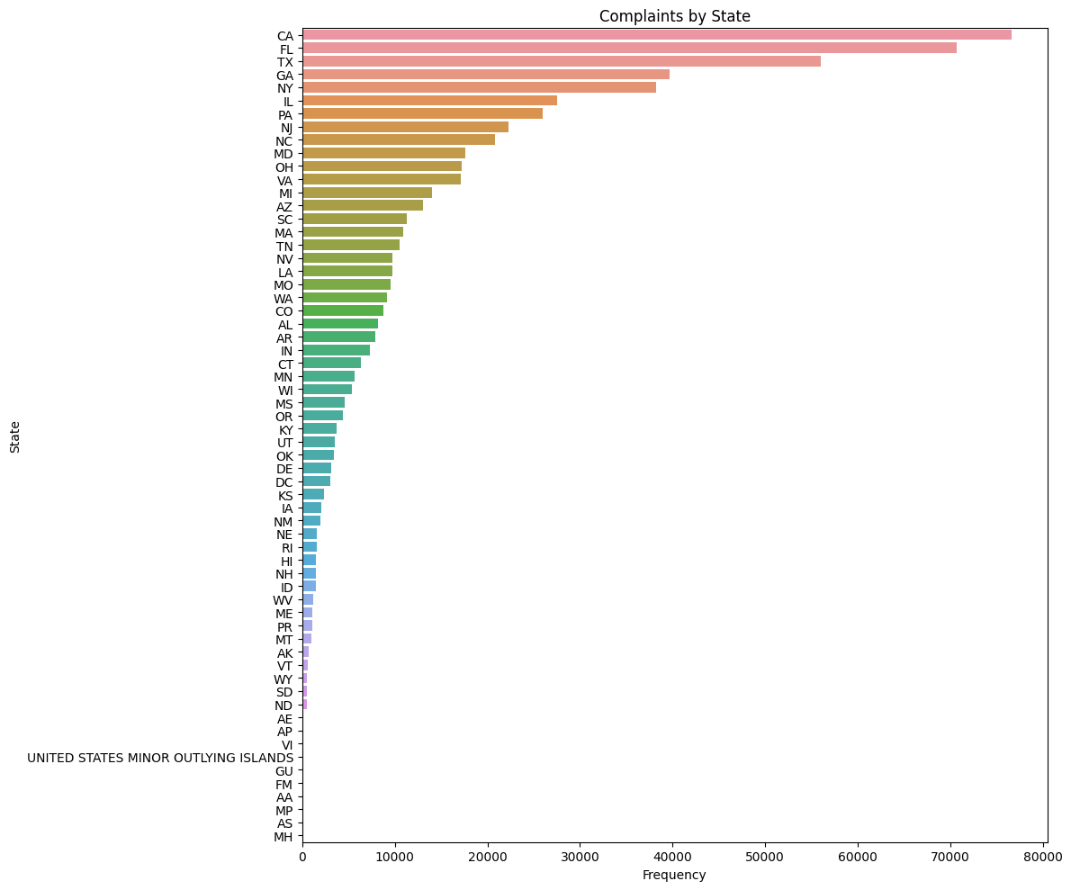

*Fig. 6. Complaints by state.*

So, California got the largest share of complaints, followed by Florida and Texas. At the end are tiny military areas of operations with two-letter postal designations, having 1 or 2 complaints. Overall distribution of complaints among states is quite smooth, probably in line with the state population (no specific analysis for rates per capita was run).

If we further structure this chart by companies involved, we will suddenly learn that Florida in fact leads in complaints on credit reporting issues, while California lags behind.

Heading companies in the number of complaints are three credit reporting companies. This is in line with the fact that we have got the max number of complaints on the issues of credit reporting errors. These are prevalent in the most populated states, like Florida and California.

Also, we could take notice that these credit reporting companies get more complaints from less populated states, than large banks (next three on the following chart) get from the most populated ones. It highlights the importance of credit reporting issues.

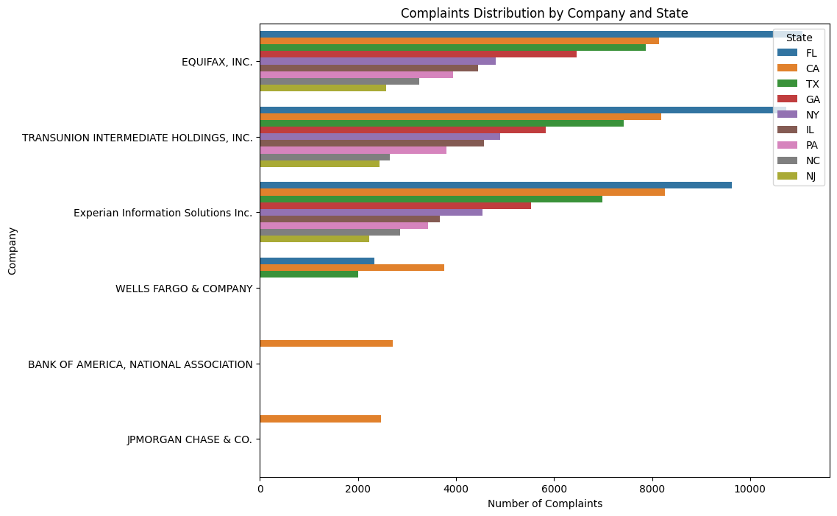

*Fig. 7. Number of complaints by involved company and State*

The next three companies depicted here are banks, and they are mostly involved in complaints on transaction and loan-related issues. There is a special tendency to complain about credit reporting in Florida and about mortgages in California (where house prices are so crazy, it’s very relatable).

Could we see any tendency in companies, involved in complaints on specific products? We already see that three credit reporting companies are in the ‘lead’, does it hold for other products? Let’s run a few tests:

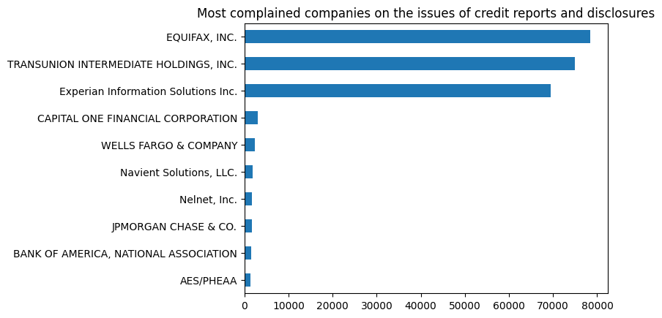

*Fig. 8. Complaints about credit reporting, by company*

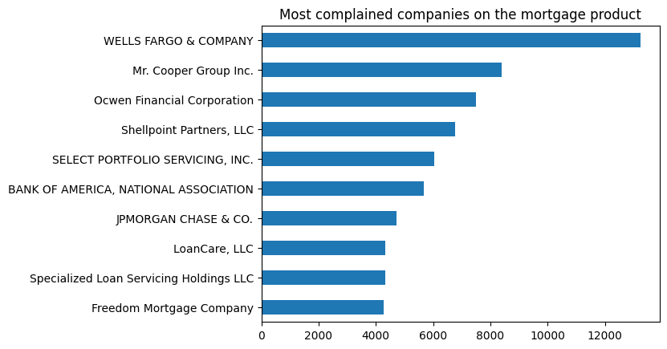

*Fig 9. Complaints about mortgages, by company*

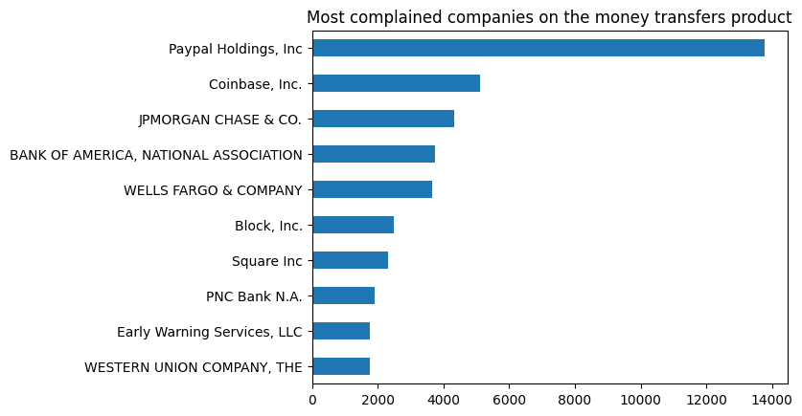

*Fig 10. Complaints about money transfers, by company*

Our hypothesis seems to work - specific companies are notorious for their errors (or just monopolies). Checks were run for other products also, but distributions for other products were not so apparently skewed.

Are these complaints actual? Meaning, are there many complaints that have not been resolved in some way?

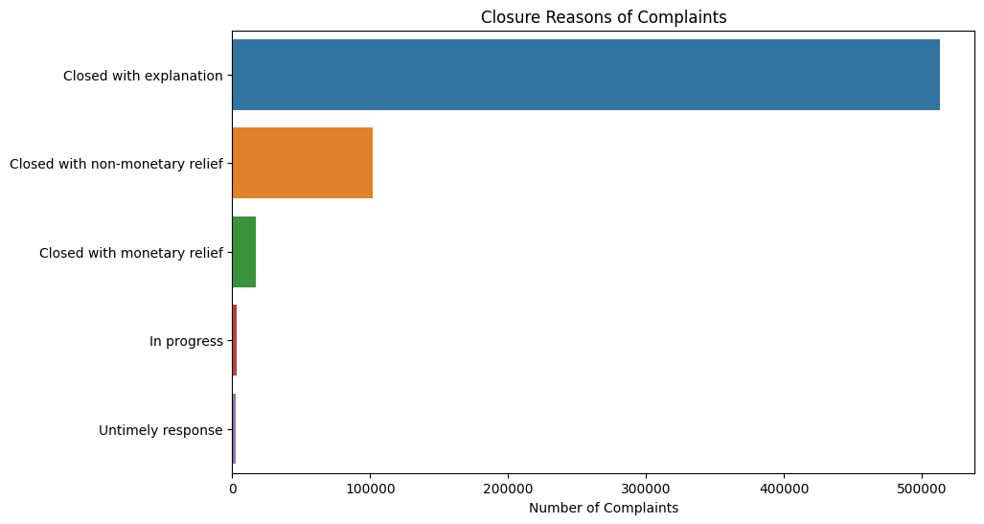

*Fig. 11. Status of complaint, by number.*

It’s very obvious that there is a tiny share of untimely handled complaints, or those still in progress. The majority of complaints have been resolved in some way.

So, these findings allow our FAQ to be targeted to consumers that come from a specific state or complain about a specific company.

### Timely response of the company

We have 545 companies who don't respond on time to customers’ complaints (0% timely response rate), indicating a potential area for regulatory attention or improvement in customer service practices. The list is too large to attach. We show the chart here:

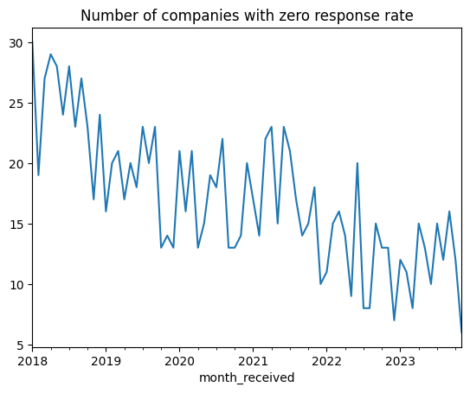

*Fig. 12. Monthly number of companies with 0 of timely_response rate.*

These are the companies that are explicitly marked with “No” in the “Timely response” field, so that we know these are not fresh complaints that hadn’t been answered yet due to timing. Their quantity goes down through the years, so customer service must be developing well.

### Adding the issues and products that appeared only in 2023 and could become hot topics

We have also identified specific issues and subproducts that appeared only in 2023, when the database (or input program) underwent another change:

New Issues in 2023:

* 'Trouble accessing funds in mobile/digital wallet',
* 'Electronic communications',
* 'Unauthorized withdrawals/charges',
* 'Problems receiving advance',
* 'Issue with income share agreement',
* 'Issue where lender is school',
* "Didn't provide services promised".

New Sub-Products in 2023:

* 'Other advances of future income',
* 'USDA mortgage',
* 'Manufactured home loan',
* 'Earned wage access',
* 'Tax refund anticipation loan or check',
* 'Student loan debt relief',
* 'Rental debt',
* 'Telecommunications debt'.

There were also a number of new subissues, some of them older subissues rephrased and some in fact new. Issues related to digital wallets, electronic comms, or new products (like USDA mortgage) should be included in the FAQ. But this filtering needs deeper financial knowledge, so we should leave the choice to the pros.

## Final result

So, the proposal for the FAQ is to have a table of issues cross-sectioned with products, with links to subsections in the place of numbers in Table 2. Each link would open a page with a list of most important sub issues cross-linked with most important sub products, and have a link at the intersection, leading to the answer.

*NB: This table could be derived also in an alternative method, skipping the data cleaning process. If we cut the original database by keywords, keep only the necessary years, and pivot products against issues, filtering out the cells that provide for less than 0.5% of the dataset, we will get a very similar table, with some variations in wordings for issues. But the amount of work for the FAQ will be roughly the same. The alternative approach is kept in the project notebook, to be used in future, in case the database structure changes again - it will continue doing the job.*

*Sample of the final product:*

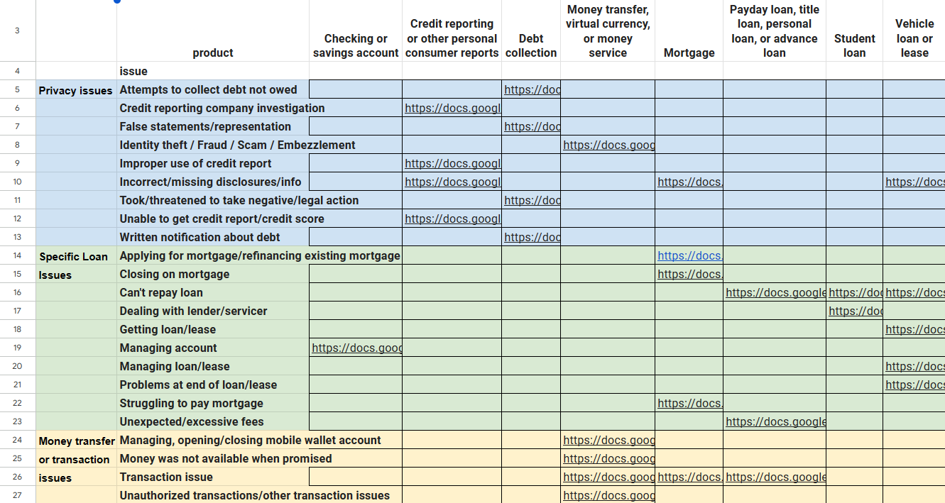

Where each link points to the sub-table (see sub-tables below in Appendix).

Address for the source:

<https://docs.google.com/spreadsheets/d/e/2PACX-1vRjaHeSTgtCxyIinDEFPEbn-sQVubXo2LgdfTjsfRaHxrWwyoupSet1kCSrOBJkmfm3wMxADd8DbyEj/pubhtml>

FAQ entries:

Level 1 (table above): 29 entries. Plus one entry for New issues (prev. page)

Level 2 (Appendix): 88 entries. Plus entries for New issues (tbd)

## Appendix: Tables for the most important combinations of Subissues and Subproducts.

*Note: when complaints are evenly dispersed among subissues and subproducts, this table may be empty. In this case, maybe a general FAQ page is appropriate for the case.*

*When there is a number, it should be substituted with a link to the FAQ page.*

These rows/columns are a selection from the whole variety of subproducts / subissues combinations. We have chosen only those where the number of complaints is over 1000. Total number of complaints covered by this selection adds up to 84% of all complaints related to Loans and Money transfers. We feel this is a reasonable threshold.

It allows the FAQ producing team to decide whether to write a general page on the Product/Issue combination, or to go into details and make each number in the sub-table into a link to a specific FAQ page.

| Applying for mortgage/refinancing existing mortgageMortgage |  |  |  |  |  |
| --- | --- | --- | --- | --- | --- |
| **sub_product** | **Conventional home mortgage** | **FHA mortgage** | **Home equity loan or line of credit (HELOC)** | **Other type of mortgage** | **VA mortgage** |
| **sub_issue** |  |  |  |  |  |
| **ISSUE Applying for mortgage/refinancing existing mortgage** | 11143 | 2694 | 1652 | 1493 | 1766 |
| --------------------------------- |  |  |  |  |  |
| Attempts to collect debt not owedDebt collection |  |  |  |  |  |
| **sub_product** | **I do not know** | **Medical debt** | **Other debt** |  |  |
| **sub_issue** |  |  |  |  |  |
| **Debt is not yours** | 3294 | 1348 | 3442 |  |  |
| **Debt was paid** |  |  | 1232 |  |  |
| **Debt was result of identity theft** | 2497 |  | 1675 |  |  |
| --------------------------------- |  |  |  |  |  |
| Can't repay loanPayday loan, title loan, personal loan, or advance loan |  |  |  |  |  |
| **sub_product** | **Installment loan** | **Payday loan, title loan, personal loan, or advance loan** |  |  |  |
| **sub_issue** |  |  |  |  |  |
| **ISSUE Can't repay loan** | 1665 | 1301 |  |  |  |
| --------------------------------- |  |  |  |  |  |
| Can't repay loanStudent loan |  |  |  |  |  |
| **sub_product** | **Federal student loan servicing** | **Private student loan** |  |  |  |
| **sub_issue** |  |  |  |  |  |
| **Can't get other flexible options for repaying loan** | 1971 | 1866 |  |  |  |
| **Problem lowering monthly payments** | 1061 | 1085 |  |  |  |
| --------------------------------- |  |  |  |  |  |
| Can't repay loanVehicle loan or lease |  |  |  |  |  |
| **sub_product** | **Loan** |  |  |  |  |
| **sub_issue** |  |  |  |  |  |
| **Denied request to lower payments** | 2325 |  |  |  |  |
| **Lender trying to repossess/disable vehicle** | 2280 |  |  |  |  |
| **Loan balance remaining after vehicle is repossessed and sold** | 2253 |  |  |  |  |
| --------------------------------- |  |  |  |  |  |
| Closing on mortgageMortgage |  |  |  |  |  |
| **sub_product** | **Conventional home mortgage** | **FHA mortgage** | **Other type of mortgage** | **VA mortgage** |  |
| **sub_issue** |  |  |  |  |  |
| **ISSUE Closing on mortgage** | 6520 | 1802 | 1277 | 1030 |  |
| --------------------------------- |  |  |  |  |  |
| Credit reporting company investigationCredit reporting or other personal consumer reports |  |  |  |  |  |
| **sub_product** | **Credit reporting** |  |  |  |  |
| **sub_issue** |  |  |  |  |  |
| **Difficulty submitting dispute/getting information about dispute over phone** | 3001 |  |  |  |  |
| **Investigation took more than 30 days** | 11753 |  |  |  |  |
| **Problem with personal statement of dispute** | 2486 |  |  |  |  |
| **Their investigation did not fix error on report** | 59371 |  |  |  |  |
| **Was not notified of investigation status/results** | 8326 |  |  |  |  |
| --------------------------------- |  |  |  |  |  |
| Dealing with lender/servicerStudent loan |  |  |  |  |  |
| **sub_product** | **Federal student loan servicing** | **Private student loan** |  |  |  |
| **sub_issue** |  |  |  |  |  |
| **Don't agree with fees charged** | 1617 |  |  |  |  |
| **ISSUE Problem with customer service** | 3203 |  |  |  |  |
| **Need information about loan balance/loan terms** | 1847 |  |  |  |  |
| **Received bad information about loan** | 8248 | 2031 |  |  |  |
| **Trouble with how payments are being handled** | 7290 | 2124 |  |  |  |
| --------------------------------- |  |  |  |  |  |
| False statements/representationDebt collection |  |  |  |  |  |
| **sub_product** | **Other debt** |  |  |  |  |
| **sub_issue** |  |  |  |  |  |
| **Attempted to collect wrong amount** | 1284 |  |  |  |  |
| --------------------------------- |  |  |  |  |  |
| Getting loan/leaseVehicle loan or lease |  |  |  |  |  |
| **sub_product** | **Loan** |  |  |  |  |
| **sub_issue** |  |  |  |  |  |
| **Credit denial** | 1345 |  |  |  |  |
| **Fraudulent loan** | 2676 |  |  |  |  |
| --------------------------------- |  |  |  |  |  |
| Identity theft / Fraud / Scam / EmbezzlementMoney transfer, virtual currency, or money service |  |  |  |  |  |
| **sub_product** | **Domestic (US) money transfer** | **International money transfer** | **Mobile or digital wallet** | **Virtual currency** |  |
| **sub_issue** |  |  |  |  |  |
| **ISSUE Identity theft / Fraud / Scam / Embezzlement** | 7129 | 1706 | 6623 | 3108 |  |
| --------------------------------- |  |  |  |  |  |
| Improper use of credit reportCredit reporting or other personal consumer reports |  |  |  |  |  |
| **sub_product** | **Credit reporting** |  |  |  |  |
| **sub_issue** |  |  |  |  |  |
| **Credit inquiries on report that don't recognize** | 13170 |  |  |  |  |
| **Reporting company used report improperly** | 20397 |  |  |  |  |
| --------------------------------- |  |  |  |  |  |
| Incorrect/missing disclosures/infoCredit reporting or other personal consumer reports |  |  |  |  |  |
| **sub_product** | **Credit reporting** |  |  |  |  |
| **sub_issue** |  |  |  |  |  |
| **Account information incorrect** | 18364 |  |  |  |  |
| **Account status incorrect** | 22271 |  |  |  |  |
| **Information belongs to someone else** | 85802 |  |  |  |  |
| **Information that should be on report is missing** | 2335 |  |  |  |  |
| **Old information reappears/never goes away** | 3393 |  |  |  |  |
| **Personal information incorrect** | 5384 |  |  |  |  |
| **Public record information inaccurate** | 2539 |  |  |  |  |
| --------------------------------- |  |  |  |  |  |
| Incorrect/missing disclosures/infoMortgage |  |  |  |  |  |
| **sub_product** | **Conventional home mortgage** |  |  |  |  |
| **sub_issue** |  |  |  |  |  |
| **Account status incorrect** | 1011 |  |  |  |  |
| --------------------------------- |  |  |  |  |  |
| Incorrect/missing disclosures/infoVehicle loan or lease |  |  |  |  |  |
| **sub_product** | **Loan** |  |  |  |  |
| **sub_issue** |  |  |  |  |  |
| **Account information incorrect** | 1369 |  |  |  |  |
| **Account status incorrect** | 1423 |  |  |  |  |
| --------------------------------- |  |  |  |  |  |
| Managing accountChecking or savings account |  |  |  |  |  |
| **sub_product** | **Checking account** |  |  |  |  |
| **sub_issue** |  |  |  |  |  |
| **Deposits/withdrawals** | 3347 |  |  |  |  |
| **Problem using debit/ATM card** | 1375 |  |  |  |  |
| --------------------------------- |  |  |  |  |  |
| Managing loan/leaseVehicle loan or lease |  |  |  |  |  |
| **sub_product** | **Lease** | **Loan** |  |  |  |
| **sub_issue** |  |  |  |  |  |
| **Billing/statement issues** | 1103 | 7143 |  |  |  |
| **Fees charged** |  | 2258 |  |  |  |
| **Interest rate** |  | 1514 |  |  |  |
| **Problem with additional products/services purchased with loan** |  | 1715 |  |  |  |
| --------------------------------- |  |  |  |  |  |
| Managing, opening/closing mobile wallet accountMoney transfer, virtual currency, or money service |  |  |  |  |  |
| **sub_product** | **Mobile or digital wallet** |  |  |  |  |
| **sub_issue** |  |  |  |  |  |
| **ISSUE Managing, opening/closing mobile wallet account** | 7703 |  |  |  |  |
| --------------------------------- |  |  |  |  |  |
| Money was not available when promisedMoney transfer, virtual currency, or money service |  |  |  |  |  |
| **sub_product** | **Domestic (US) money transfer** | **International money transfer** | **Virtual currency** |  |  |
| **sub_issue** |  |  |  |  |  |
| **ISSUE Money was not available when promised** | 2384 | 1918 | 1610 |  |  |
| --------------------------------- |  |  |  |  |  |
| Problems at end of loan/leaseVehicle loan or lease |  |  |  |  |  |
| **sub_product** | **Loan** |  |  |  |  |
| **sub_issue** |  |  |  |  |  |
| **Problem with paying off loan** | 1844 |  |  |  |  |
| **Unable to receive car title/other issues after loan is paid off** | 3079 |  |  |  |  |
| --------------------------------- |  |  |  |  |  |
| Struggling to pay mortgageMortgage |  |  |  |  |  |
| **sub_product** | **Conventional home mortgage** | **FHA mortgage** | **Home equity loan or line of credit (HELOC)** | **Other type of mortgage** | **VA mortgage** |
| **sub_issue** |  |  |  |  |  |
| **ISSUE Struggling to pay mortgage** | 21616 | 7160 | 1448 | 3477 | 1930 |
| --------------------------------- |  |  |  |  |  |
| Took/threatened to take negative/legal actionDebt collection |  |  |  |  |  |
| **sub_issue** |  |  |  |  |  |
| --------------------------------- |  |  |  |  |  |
| Transaction issueMoney transfer, virtual currency, or money service |  |  |  |  |  |
| **sub_product** | **Domestic (US) money transfer** | **International money transfer** | **Virtual currency** |  |  |
| **sub_issue** |  |  |  |  |  |
| **ISSUE Transaction issue** | 4654 | 2685 | 2375 |  |  |
| --------------------------------- |  |  |  |  |  |
| Transaction issueMortgage |  |  |  |  |  |
| **sub_product** | **Conventional home mortgage** | **FHA mortgage** | **Home equity loan or line of credit (HELOC)** | **Other type of mortgage** | **VA mortgage** |
| **sub_issue** |  |  |  |  |  |
| **ISSUE Transaction issue** | 42690 | 8748 | 3582 | 4910 | 4413 |
| --------------------------------- |  |  |  |  |  |
| Transaction issuePayday loan, title loan, personal loan, or advance loan |  |  |  |  |  |
| **sub_product** | **Installment loan** | **Personal line of credit** |  |  |  |
| **sub_issue** |  |  |  |  |  |
| **ISSUE Transaction issue** | 2612 | 1282 |  |  |  |
| --------------------------------- |  |  |  |  |  |
| Unable to get credit report/credit scoreCredit reporting or other personal consumer reports |  |  |  |  |  |
| **sub_product** | **Credit reporting** |  |  |  |  |
| **sub_issue** |  |  |  |  |  |
| **Other issues getting report/credit score** | 2765 |  |  |  |  |
| --------------------------------- |  |  |  |  |  |
| Unauthorized transactions/other transaction issuesMoney transfer, virtual currency, or money service |  |  |  |  |  |
| **sub_product** | **Mobile or digital wallet** |  |  |  |  |
| **sub_issue** |  |  |  |  |  |
| **ISSUE Unauthorized transactions/other transaction issues** | 5503 |  |  |  |  |
| --------------------------------- |  |  |  |  |  |
| Unexpected/excessive feesPayday loan, title loan, personal loan, or advance loan |  |  |  |  |  |
| **sub_product** | **Installment loan** | **Payday loan, title loan, personal loan, or advance loan** | **Personal line of credit** |  |  |
| **sub_issue** |  |  |  |  |  |
| **ISSUE Unexpected/excessive fees** | 3156 | 1685 | 1421 |  |  |
| --------------------------------- |  |  |  |  |  |
| Written notification about debtDebt collection |  |  |  |  |  |
| **sub_issue** |  |  |  |  |  |
| --------------------------------- |  |  |  |  |  |